Church of the Holy Spirit

2019 Holy Week Schedule
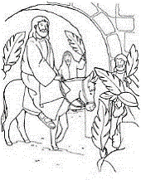
PALM SUNDAY – April 14: PASSION of OUR LORD
Mass Times: Saturday 5:00pm - Solemn Entrance
Sunday 8:00am - Solemn Entrance
Sunday 10:30am - Procession with Palms
Confessions, your choice of about 8 Deanery Priests: Sunday, April 14 at 3:30pm

Monday – April 15
Masses: 8:10am
5:00pm Chrism Mass at Cathedral in Lincoln. All are invited to attend.
Confessions: before 8:10am Mass
Tuesday - April 16
Mass: 8:10am
Confessions: before 8:10am Mass and 4:00pm - 5:00pm
Wednesday - April 17
Mass: 8:10am
Confessions: before 8:10am Mass, 12:00 noon - 1:00pm, and 7:30pm - 8:30pm
Stations of the Cross: 5:30pm

All parishioners are invited and encouraged to come all three days of the Triduum
(Thursday, Friday and Saturday).

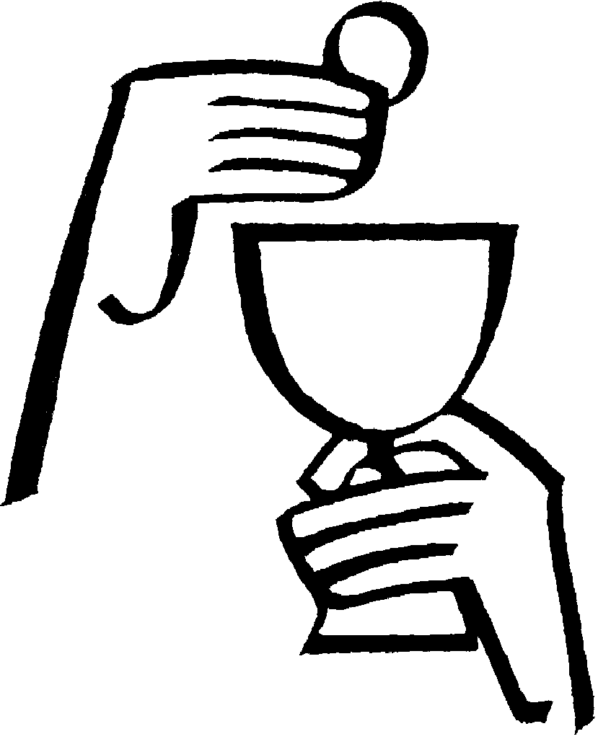
HOLY THURSDAY – April 18
This is the feast of the Institution of the Holy Eucharist.
Morning Prayer 8:00am
Mass of the Last Supper - 7:30pm
(Offertory collection for Catholic Social Services, Lincoln)
Adoration after the 7:30pm Mass until 12:00 Midnight.
All parishioners are asked to come for one hour of adoration.
Families with names beginning: H-L 8:00pm - 9:00pm
M-R 9:00pm - 10:00pm
S-Z 10:00pm - 11:00pm
A-G 11:00pm - 12:00 Midnight
If you are unable to attend at the hour specified, feel free to come anytime
until Midnight.
Confessions: 4:00pm - 5:00pm, after the 7:30pm Mass until finished,
9:00pm until finished, 10:00pm until finished, and 11:00pm until finished

(over)

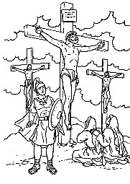
GOOD FRIDAY – April 19
Morning Prayer - 8:00am
Stations of the Cross – Noon
Medical Description of the Passion – Directly after Stations
Seven Last Words: 3:00pm
Liturgy of Good Friday - 7:30pm
This is the one to attend if you attend only one of today’s services.
The Good Friday Liturgy consists of the reading of the Passion, Veneration of the Cross, and Holy Communion.
Offertory collection for the Holy Land.
Confessions: After all services until all are heard.
Note: Good Friday is a day of fasting for all Catholics between the ages of 18 & 59 and a day of Abstinence from meat for all Catholics 14 years and older.

NO CONFESSIONS ARE SCHEDULED FOR HOLY SATURDAY

Blessing of the Easter bread, children’s Easter baskets and food for Easter dinner will be after Masses of the Easter Vigil and Easter Sunday. There will be a table near the altar.

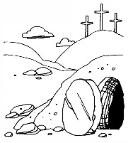
HOLY SATURDAY – APRIL 20
Morning Prayer - 8:00am
THE ONLY MASS OF THE DAY….
The Mass of the Easter Vigil – 8:30pm
There are four main events celebrated at the Easter Vigil:
- The lighting of the new fire and Easter Candle, representing the Risen Lord.
- The readings from the Old Testament unfolding the salvation history of the human race. Readings 1-3-5-7
- The blessing of the Easter water recalling our entrance into redemption by our baptism, and initiation of catechumens and reception of other Christians into full communion.
- The Mass of the Resurrection.
This is the most important and most joyous service of the entire year. We prayerfully urge all to come. This is the story of our redemption. The Easter Vigil Mass counts for your Sunday obligation and is, in fact, the principal Mass of the entire year.

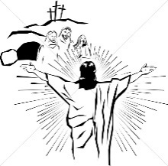
EASTER SUNDAY - APRIL 21
Regular Sunday Mass schedule: 8:00am 10:30am
(Renewal of baptismal promises at both Masses)
NO CONFESSIONS ARE SCHEDULED FOR EASTER SUNDAY

Note for later during Eastertide…

• April 27 Mass at 4pm, not 5pm. (Spring Dinner)
• FIRST COMMUNION – Saturday, May 4 at 5:00pm
Mass for First Holy Communion of our Second Graders at Church of the Holy Spirit. **This is a regularly scheduled weekend Mass, but it is advisable to attend a Mass on Sunday, if you are not with a First Communicant, due to the expected large crowd.

