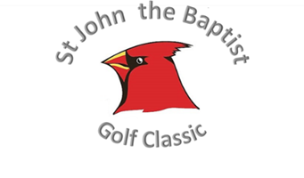
Bay Hills Golf Course Remit to:
Saturday, June 15, 2019 Knights of Columbus Council 1966
12:00 PM Shotgun Start 1609 Hedgeapple Rd
Plattsmouth, NE 68408
Sponsorship Tiers
StJB Golf Classic Tax ID # for IRS charitable deduction | 53-0196617
Hole Sponsor $125.00
(Includes a sign with your name or business name printed.)
------------------------------------------------------------------------------------------------------------------
Corporate/Company Sponsor + 4 golfers $400.00
(Includes a sign with your name or business name printed + 4 golfers.)
------------------------------------------------------------------------------------------------------------------
Hole in One Sponsorship (Greg Young Chevrolet of Plattsmouth) Filled
(Includes large sign along with hole prize details.)
------------------------------------------------------------------------------------------------------------------
*Principal Event Sponsor* $1,000+
*We will contact you directly to collectively plan the details of your principal event sponsorship.*

Golf Participant Tiers

Dinner-Only Option per Individual $20.00
Individual Participant Registration $80.00
(Includes golf and dinner)

Foursome Participant Registration $320.00
(Includes golf and Dinner)
Please return this slip with your sponsorship and/or participant registration by June 7, 2019
 | $125 | Hole Sponsor |  | $20 | Dinner-Only  (Use back if necessary for extra diners) |  | $400 | Corporate/Company Sponsor  + 4 Golfers & Dinner
 | FILLED! | Hole in One Sponsorship |  | $320 | 4-Some Golf Registration |  | $80 | Individual Participant Registration
 |  |  | $1000+ Principal Event Sponsor
Sponsorship sign: please indicate the family name(s), memorial name(s), personal name(s), business name(s) exactly as you would like printed. If you purchased a sponsorship with golfers, or are registering as a participant foursome or individual, please list individual names if you know them for sponsorship signs and/or golf cart signs. Thank you for your consideration. Questions? Call Mike at 402-296-5422 or email to michael.vaughn@windstream.net

__________________________________________________________________

